**Program 9: Print any pattern with entered character**

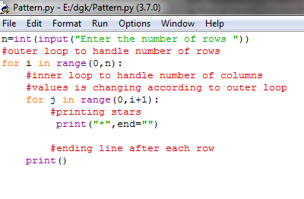

**Output :**

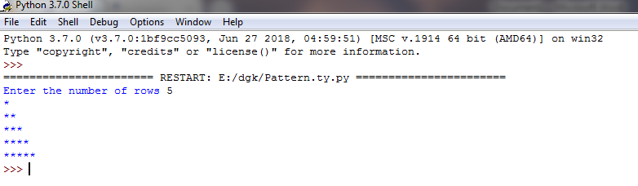

**Program 8 : Reverse the entered string**

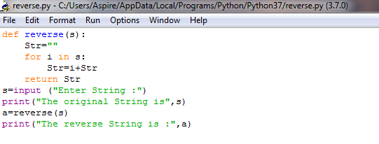

**Output :**

